//LAB 7

//lex_analyzer.h file
#include <stdio.h>
#include <stdlib.h>
#include <ctype.h>
#include <string.h>

const char* keywords[] = {"int", "return", "for", "while", "do",
"else", "case", "break", "unsigned",
"const"};
const char *datypes[]={"int","char","void","float","bool"};

//check if the string is a datatype or not
int isdtype(char *w)
{
int i;
for(i=0;i<sizeof(datypes)/sizeof(char*);i++)
{
if(strcmp(w,datypes[i])==0)
{
return 1;
}
}
return 0;
}

//check whether the string is a keyword or not
int isKeyword(char *w)
{

int i;

for(i=0;i<sizeof(keywords)/sizeof(char*);i++)

{

if(strcmp(w,keywords[i])==0)

{

return 1;

}

}

return 0;
}
struct token
{
char lexeme[128];
unsigned int row,col;
char type[64];
};
struct sttable
{
int sno;
char lexeme[128];
char dtype[64];
char type[64];
int size;
};

int findTable(struct sttable *tab,char *nam,int n)
{
int i=0;
for(i=0;i<n;i++)
{
if(strcmp(tab[i].lexeme,nam)==0)
{
return 1;
}
}
return 0;
}
struct sttable fillTable(int sno,char *lexn,char *dt,char *t,int s)
{
struct sttable tab;
tab.sno=sno;
strcpy(tab.lexeme,lexn);
strcpy(tab.dtype,dt);
strcpy(tab.type,t);
tab.size=s;
return tab;
}
void printTable(struct sttable *tab,int n)
{
for(int i=0;i<n;i++)
{
printf("%d %s %s %s %d\n",tab[i].sno,tab[i].lexeme,tab[i].dtype,tab[i].type,tab[i].size);
}
}
static int row=1,col=1;
char buf[2048];
char dbuf[128];
int ind=0;
const char specialsymbols[]={'?',';',':',','};
const char arithmeticsymbols[]={'*'};
int charIs(int c,const char *arr)
{
int len;
if(arr==specialsymbols)
{
len=sizeof(specialsymbols)/sizeof(char);
}
else if(arr==arithmeticsymbols)
{
len=sizeof(arithmeticsymbols)/sizeof(char);
}
for(int i=0;i<len;i++)
{
if(c==arr[i])
{
return 1;
}
}
return 0;
}

//for lexemes that are a single character only
void fillToken(struct token *tkn,char c,int row,int col, char *type)
{
tkn->row=row;
tkn->col=col;
strcpy(tkn->type,type);
tkn->lexeme[0]=c;
tkn->lexeme[1]='\0';
}
void newLine()
{
++row;
col=1;
}
int sz(char *w)
{
if(strcmp(w,"int")==0)
return 4;
if(strcmp(w,"char")==0)
return 1;
if(strcmp(w,"void")==0)
return 0;
if(strcmp(w,"float")==0)
return 8;
if(strcmp(w,"bool")==0)
return 1;
}
struct token getNextToken(FILE *fa)
{
int c;
struct token tkn=
{
.row=-1
};
int gotToken=0;
while(!gotToken && (c=fgetc(fa))!=EOF)
{

if(charIs(c,specialsymbols)) //check if the character is a special symbol
{
fillToken(&tkn,c,row,col,"special symbol");
gotToken=1;
++col;
}
else if(charIs(c,arithmeticsymbols)) //check for arithmetic symbol
{
fseek(fa,-1,SEEK_CUR);
c=getc(fa);
if(isalnum(c)){
fillToken(&tkn,c,row,col,"arithmetic operator");
gotToken=1;
++col;
}
fseek(fa,1,SEEK_CUR);
}
else if(c=='(')
{
fillToken(&tkn,c,row,col,"left bracket");
gotToken=1;
col++;
}
else if(c==')')
{
fillToken(&tkn,c,row,col,"right bracket");
gotToken=1;
col++;
}
else if(c=='{')
{
fillToken(&tkn,c,row,col,"LC");
gotToken=1;
col++;
}
else if(c=='}')
{
fillToken(&tkn,c,row,col,"RC");
gotToken=1;
col++;
}
else if(c=='[')
{
fillToken(&tkn,c,row,col,"LS");
gotToken=1;
col++;
}
else if(c==']')
{
fillToken(&tkn,c,row,col,"RS");
gotToken=1;
col++;
}
else if(c=='+')
{
int x=fgetc(fa);
if(x!='+')
{
fillToken(&tkn,c,row,col,"arithmetic operator");
gotToken=1;
col++;
fseek(fa,-1,SEEK_CUR);
}
else
{
fillToken(&tkn,c,row,col,"unary operator");
strcpy(tkn.lexeme,"++");
gotToken=1;
col+=2;
}
}
else if(c=='-')
{
int x=fgetc(fa);
if(x!='-')
{
fillToken(&tkn,c,row,col,"arithmetic operator");
gotToken=1;
col++;
fseek(fa,-1,SEEK_CUR);
}
else
{
fillToken(&tkn,c,row,col,"unary op");
strcpy(tkn.lexeme,"++");
gotToken=1;
col+=2;
}
}
else if(c=='=')
{
int x=fgetc(fa);
if(x!='=')
{
fillToken(&tkn,c,row,col,"assignment op");
gotToken=1;
col++;
fseek(fa,-1,SEEK_CUR);
}
else
{
fillToken(&tkn,c,row,col,"relational op");
strcpy(tkn.lexeme,"++");
gotToken=1;
col+=2;
}
}
else if(isdigit(c)) //condition for checking a number
{
fillToken(&tkn,c,row,col++,"number");
int j=1;
while((c=fgetc(fa))!=EOF && isdigit(c))
{
tkn.lexeme[j++]=c;
col++;
}
tkn.lexeme[j]='\0';
gotToken=1;
fseek(fa,-1,SEEK_CUR);
}
else if(c == '#') // for #include statements
{
while((c = fgetc(fa))!= EOF && c != '\n');
newLine();
}
else if(c=='\n') // new line statement
{
newLine();
c = fgetc(fa);
if(c == '#')
{
while((c = fgetc(fa)) != EOF && c != '\n');
newLine();
}
else if(c != EOF)
{
fseek(fa, -1, SEEK_CUR);
}
}
else if(isspace(c))
{
++col;
}
else if(isalpha(c) || c=='_') //check for identifiers
{
tkn.row=row;
tkn.col=col++;
tkn.lexeme[0]=c;
int j=1;
while((c=fgetc(fa))!=EOF && isalnum(c))
{
tkn.lexeme[j++]=c;
col++;
}
tkn.lexeme[j]='\0';
if(isKeyword(tkn.lexeme))
{
strcpy(tkn.type,"keyword");
}
else
{
strcpy(tkn.type,"identifier");
}
gotToken=1;
fseek(fa,-1,SEEK_CUR);
}
else if(c=='/')
{
int d=fgetc(fa);
++col;
if(d=='/') // single line comment
{
while((c=fgetc(fa))!= EOF && c!='\n')
{
++col;
}
if(c=='\n')
{
newLine();
}
}
else if(d=='*') // multiline comment
{
do
{
if(d=='\n')
{
newLine();
}
while((c==fgetc(fa))!= EOF && c!='*')
{
++col;
if(c=='\n')
{
newLine();
}
}
++col;
}while((d==fgetc(fa))!= EOF && d!='/' && (++col));
++col;
}
else
{
fillToken(&tkn,c,row,--col,"arithmetic op");
gotToken=1;
fseek(fa,-1,SEEK_CUR);
}
}
else if(c=='"')
{
tkn.row=row;
tkn.col=col;
strcpy(tkn.type, "string literal");
int k = 1;
tkn.lexeme[0] = '"';
while((c = fgetc(fa)) != EOF && c != '"')
{
tkn.lexeme[k++] = c;
++col;
}
tkn.lexeme[k] = '"';
gotToken = 1;
}
else if(c == '<' || c == '>' || c == '!')
{
fillToken(&tkn, c, row, col, "relational op");
++col;
int d = fgetc(fa);
if(d == '=')
{
++col;
strcat(tkn.lexeme, "=");
}
else
{
if(c == '!')
{
strcpy(tkn.type, "logical op");
}
fseek(fa, -1, SEEK_CUR);
}
gotToken = 1;
}
else if(c == '&' || c == '|')
{
int d = fgetc(fa);
if(c == d)
{
tkn.lexeme[0] = tkn.lexeme[1] = c;
tkn.lexeme[2] = '\0';
tkn.row = row;
tkn.col = col;
++col;
gotToken = 1;
strcpy(tkn.type, "logical operator");
}
else
{
fseek(fa, -1, SEEK_CUR);
}
++col;
}
else
{
++col;
}
}
//printf("token row is: %d \n", tkn.row);
return tkn;
}

#include<stdio.h>
#include<stdlib.h>
#include<ctype.h>
#include<string.h>
#include "lex_analyzer.h"
#include "initialize.h"

FILE* f1;
struct token tkn;

void Program();
void declarations();
int data_type();
void identifier_list(struct token);
void assign_stat(struct token);

void invalid(struct token* tkn)
{
printf("error at row: %d, col: %d for lexeme \" %s \" \n", tkn->row, tkn->col, tkn->lexeme);
printf("-----------------ERROR!----------------\n");
exit(0);
}

void valid()
{
printf("----------------SUCCESS!---------------\n");
exit(0);
}

void Program()
{
tkn = getNextToken(f1);
if(strcmp(tkn.lexeme, "main") == 0)
{
tkn = getNextToken(f1);
if(strcmp(tkn.lexeme, "(") == 0)
{
tkn = getNextToken(f1);
if(strcmp(tkn.lexeme, ")") == 0)
{
tkn = getNextToken(f1);
if(strcmp(tkn.lexeme, "{") == 0)
{
declarations();
//printf("after coming back from declarations\n");
tkn = getNextToken(f1);
if(strcmp(tkn.lexeme, "}") == 0)
{
return;
}
else
{

invalid(&tkn);
}
}
else
{
invalid(&tkn);
}
}
else
{
invalid(&tkn);
}
}
else
{
invalid(&tkn);
}
}
else
{
invalid(&tkn);
}
}

void declarations()
{
//printf("here in declarations\n");
tkn = getNextToken(f1);
//printf("now the token is: %s \n", tkn.lexeme);
if(data_type(tkn.lexeme))
{
tkn = getNextToken(f1);
identifier_list(tkn);
tkn = getNextToken(f1);

//printf("now then token is: %s \n", tkn.lexeme);
if(strcmp(tkn.lexeme, ";") == 0)
{
declarations();
}
else
{
invalid(&tkn);
}
}
else
{
//printf("here\n");
assign_stat(tkn);
}
}

int data_type(char* lx)
{

if(strcmp(lx, "int") == 0 || strcmp(lx, "char") == 0)
{
return 1;
}
else
{
//printf("here\n");
return 0;
}
}

void identifier_list(struct token tkn)
{
struct token tkn2;

tkn2 = tkn;
if(strcmp(tkn2.type, "identifier") == 0)
{

tkn2 = getNextToken(f1);
if(strcmp(tkn2.lexeme, ",") == 0)
{
tkn2 = getNextToken(f1);
identifier_list(tkn);
}
else if(strcmp(tkn2.lexeme, ";") == 0)
{
//printf("now the token is: %s \n", tkn2.lexeme);
fseek(f1, -1, SEEK_CUR);
return;
}
else
{
invalid(&tkn2);
}
}

}

void assign_stat(struct token tkn)
{
struct token tkn2;
if(strcmp(tkn.type, "identifier") == 0)
{
//printf("the lexeme before the error is: %s \n", tkn.lexeme);
tkn2 = getNextToken(f1);
//printf("the lexeme after the error is: %s \n", tkn.lexeme);
if(strcmp(tkn2.lexeme, "=") == 0)
{
tkn2 = getNextToken(f1);
if(strcmp(tkn2.type, "number") == 0 || strcmp(tkn2.type, "identifier"))
{
tkn2 = getNextToken(f1);
if(strcmp(tkn2.lexeme, ";") == 0)
{
return;
}
else
{
//printf("here 1 \n");
invalid(&tkn);
}
}
else
{ //printf("here 2 \n");
invalid(&tkn);
}
}
else
{ //printf("here 3 \n");
invalid(&tkn);
}
}
}

int main()
{

//initialize();
//initialize_list();
f1 = fopen("op.c","r");
// now we generate the tokens
if(f1==NULL)
{
printf("Error! File cannot be opened!\n");
return 0;
}
//struct token tkn;
struct sttable st[10][100];
int flag=0,i=0,j=0;
int tabsz[10];
char w[25];
w[0]='\0';

Program();
valid();
/*
while((tkn=getNextToken(f1)).row!=-1)
{
printf("<%s, %d, %d, %s>\n",tkn.lexeme,tkn.row,tkn.col,tkn.type);
}
*/

}

//MAIN PROGRAM
#include<stdio.h>
#include<stdlib.h>
#include<ctype.h>
#include<string.h>
#include "lex_analyzer.h"
#include "initialize.h"

FILE* f1;
struct token tkn;

void Program();
void declarations();
int data_type();
void identifier_list(struct token);
void assign_stat(struct token);

void invalid(struct token* tkn)
{
printf("error at row: %d, col: %d for lexeme \" %s \" \n", tkn->row, tkn->col, tkn->lexeme);
printf("-----------------ERROR!----------------\n");
exit(0);
}

void valid()
{
printf("----------------SUCCESS!---------------\n");
exit(0);
}

void Program()
{
tkn = getNextToken(f1);
if(strcmp(tkn.lexeme, "main") == 0)
{
tkn = getNextToken(f1);
if(strcmp(tkn.lexeme, "(") == 0)
{
tkn = getNextToken(f1);
if(strcmp(tkn.lexeme, ")") == 0)
{
tkn = getNextToken(f1);
if(strcmp(tkn.lexeme, "{") == 0)
{
declarations();
//printf("after coming back from declarations\n");
tkn = getNextToken(f1);
if(strcmp(tkn.lexeme, "}") == 0)
{
return;
}
else
{

invalid(&tkn);
}
}
else
{
invalid(&tkn);
}
}
else
{
invalid(&tkn);
}
}
else
{
invalid(&tkn);
}
}
else
{
invalid(&tkn);
}
}

void declarations()
{
//printf("here in declarations\n");
tkn = getNextToken(f1);
//printf("now the token is: %s \n", tkn.lexeme);
if(data_type(tkn.lexeme))
{
tkn = getNextToken(f1);
identifier_list(tkn);
tkn = getNextToken(f1);

//printf("now then token is: %s \n", tkn.lexeme);
if(strcmp(tkn.lexeme, ";") == 0)
{
declarations();
}
else
{
invalid(&tkn);
}
}
else
{
//printf("here\n");
assign_stat(tkn);
}
}

int data_type(char* lx)
{

if(strcmp(lx, "int") == 0 || strcmp(lx, "char") == 0)
{
return 1;
}
else
{
//printf("here\n");
return 0;
}
}

void identifier_list(struct token tkn)
{
struct token tkn2;

tkn2 = tkn;
if(strcmp(tkn2.type, "identifier") == 0)
{

tkn2 = getNextToken(f1);
if(strcmp(tkn2.lexeme, ",") == 0)
{
tkn2 = getNextToken(f1);
identifier_list(tkn);
}
else if(strcmp(tkn2.lexeme, ";") == 0)
{
//printf("now the token is: %s \n", tkn2.lexeme);
fseek(f1, -1, SEEK_CUR);
return;
}
else
{
invalid(&tkn2);
}
}

}

void assign_stat(struct token tkn)
{
struct token tkn2;
if(strcmp(tkn.type, "identifier") == 0)
{
//printf("the lexeme before the error is: %s \n", tkn.lexeme);
tkn2 = getNextToken(f1);
//printf("the lexeme after the error is: %s \n", tkn.lexeme);
if(strcmp(tkn2.lexeme, "=") == 0)
{
tkn2 = getNextToken(f1);
if(strcmp(tkn2.type, "number") == 0 || strcmp(tkn2.type, "identifier"))
{
tkn2 = getNextToken(f1);
if(strcmp(tkn2.lexeme, ";") == 0)
{
return;
}
else
{
//printf("here 1 \n");
invalid(&tkn);
}
}
else
{ //printf("here 2 \n");
invalid(&tkn);
}
}
else
{ //printf("here 3 \n");
invalid(&tkn);
}
}
}

int main()
{

//initialize();
//initialize_list();
f1 = fopen("op.c","r");
// now we generate the tokens
if(f1==NULL)
{
printf("Error! File cannot be opened!\n");
return 0;
}
//struct token tkn;
struct sttable st[10][100];
int flag=0,i=0,j=0;
int tabsz[10];
char w[25];
w[0]='\0';

Program();
valid();
/*
while((tkn=getNextToken(f1)).row!=-1)
{
printf("<%s, %d, %d, %s>\n",tkn.lexeme,tkn.row,tkn.col,tkn.type);
}
*/

}

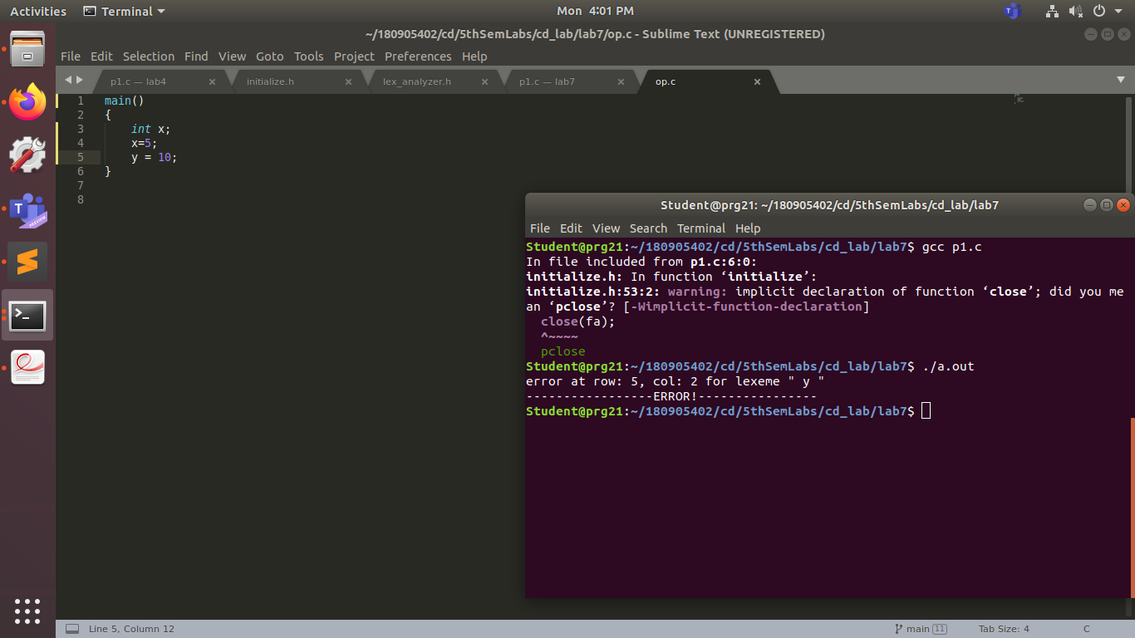
op.c is the testing file

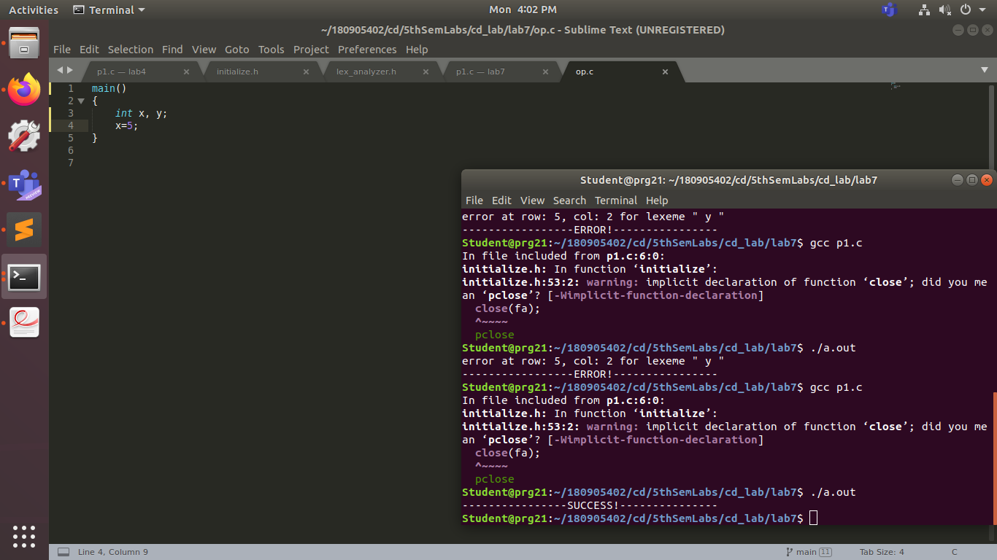
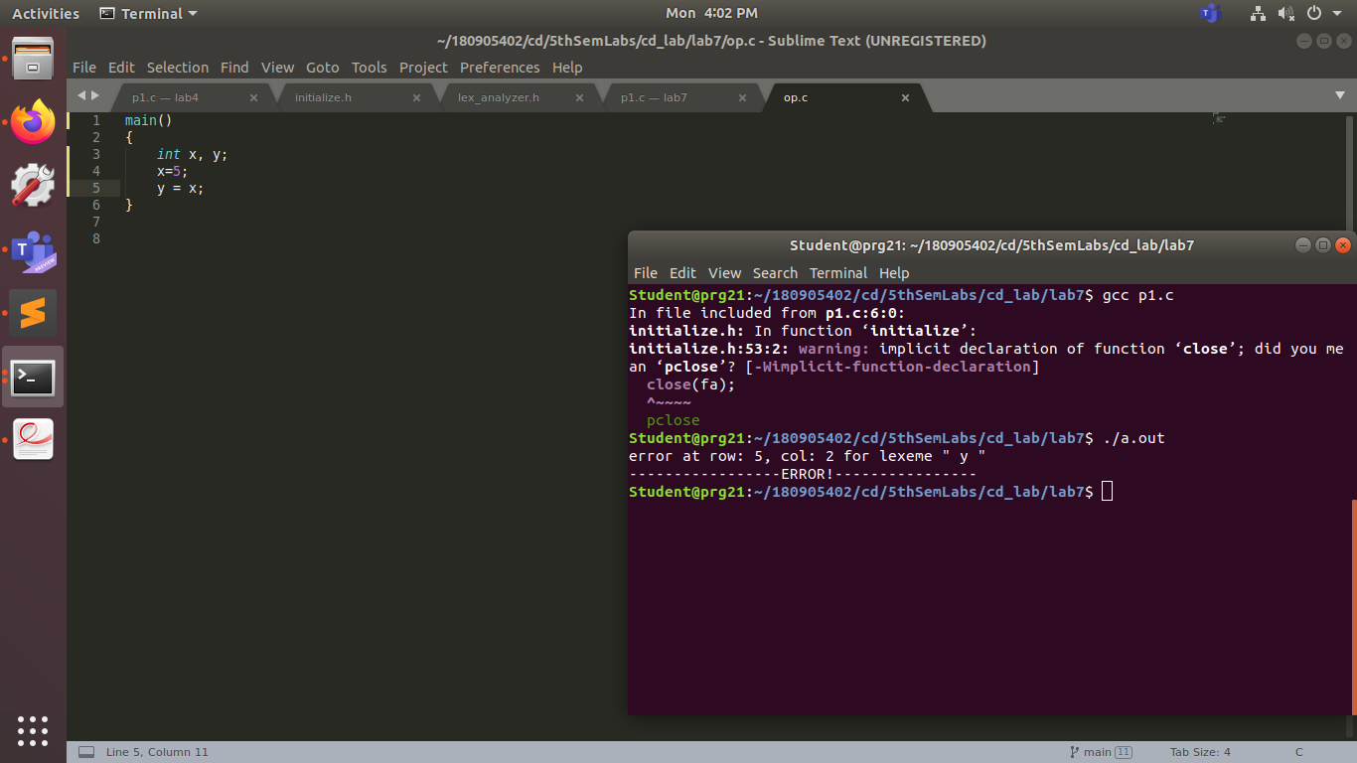
(getting a wrong answer in this case)

